Name: ______________ Ipad # ___

Topic #16

Nuclear Chemistry

1. [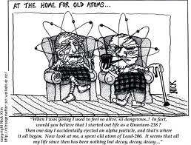](http://www.google.com/imgres?q=nuclear+decay+cartoon&um=1&hl=en&safe=active&sa=N&rls=com.microsoft:en-US&biw=1024&bih=632&tbm=isch&tbnid=oj89qLOePQoQAM:&imgrefurl=http://dhost.info/aquatsr/uranium/whereabouts1.html&docid=WGiU1prJbvo5jM&imgurl=http://dhost.info/aquatsr/uranium/Decay.gif&w=527&h=400&ei=45ChT8eTMona0QHhzZnhCA&zoom=1&iact=hc&dur=4172&sig=116860161369396602882&page=1&tbnh=140&tbnw=185&start=0&ndsp=15&ved=1t:429,r:2,s:0,i:73&tx=189&ty=211&vpx=380&vpy=149&hovh=196&hovw=258)

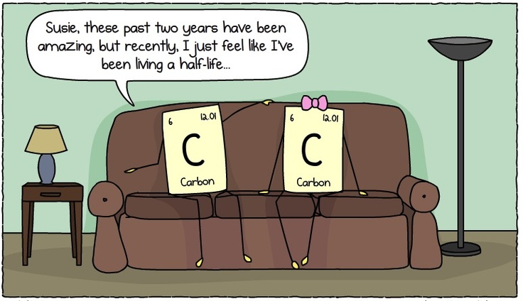[Decay.gif](http://www.google.com/imgres?q=nuclear+decay+cartoon&um=1&hl=en&safe=active&sa=N&rls=com.microsoft:en-US&biw=1024&bih=632&tbm=isch&tbnid=oj89qLOePQoQAM:&imgrefurl=http://dhost.info/aquatsr/uranium/whereabouts1.html&docid=WGiU1prJbvo5jM&imgurl=http://dhost.info/aquatsr/uranium/Decay.gif&w=527&h=400&ei=45ChT8eTMona0QHhzZnhCA&zoom=1&iact=hc&dur=4172&sig=116860161369396602882&page=1&tbnh=140&tbnw=185&start=0&ndsp=15&ved=1t:429,r:2,s:0,i:73&tx=189&ty=211&vpx=380&vpy=149&hovh=196&hovw=258)

TEXTBOOK: CHAPTER 25

HOMEWORK PACKET DUE: __________________

ONE-DAY EXAM: ____________________

Looking Ahead:

Quarterly Exam- Free Response: __________________

Quarterly Exam Multiple Choice: _________________

**Nuclear Chemistry- Study Guide**

1. **Radioactivity**- decay of an unstable nucleus into a more stable nucleus
2. **Transmutations-**

**Natural Transmutation**- spontaneous decay

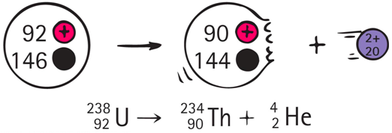

**Artificial transmutation**- when a normally stable atom is bombarded (look for 2 things on the left side of the reaction: one element and one particle)

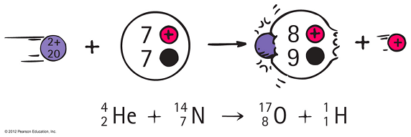

1. **Decay particles (Table O in the chemistry reference tables)**

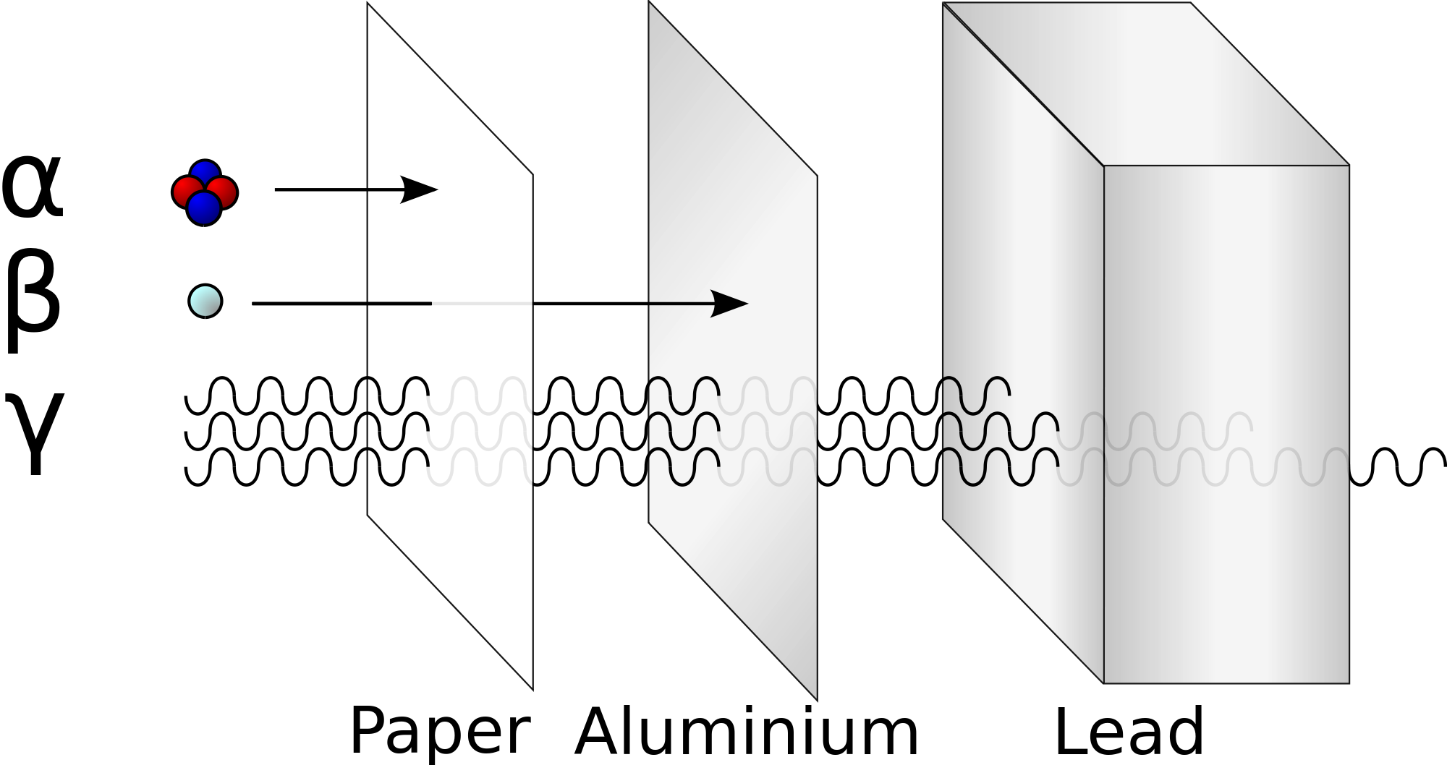

**Alpha**

**Beta**

**Gamma**

1. 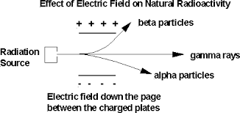Separating nuclear decay particle emissions – pass all particles through a magnetic or electric field
2. 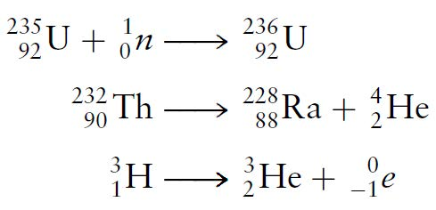**Balancing nuclear equations**: The sum of atomic #’s and the mass #’s on both sides must be equal.
3. **Half Life** – Time it takes for half of the mass to decay. The half-life on an element **NEVER** changes.
4. **Nuclear Reactions**

|  |  |
| --- | --- |
| **Nuclear Fission**  When a nucleus fissions, it splits into several smaller fragments |  |
| **Nuclear Fusion**  A nuclear reaction in which two or more atomic nuclei come very close and then collide at a very high speed and join to form a new type of atomic nucleus. |  |

* **Binding energy -** the energy that holds a nucleus together, equal to the mass defect of the nucleus.

1. **Mass defect-** The amount by which the mass of an atomic nucleus is less than the sum of the masses of its constituent particles.
2. **Nuclear Reactors** – device used for controlling nuclear fission reactions so that energy can be liberated and be converted to useful energy

A) **Breeder reactor** – produces new source of fuel for nuclear reactor

B) **Fission reactor** – produces fuel from the fission of Uranium235

C) **Fusion reactor** – fuel is deuterium (small and inexpensive) clean process, gives off huge burst of energy but short lived, produces stable isotope (no radioactive wastes) needs high temperature, and research is expensive. Occurs naturally on the sun, between He and H atoms.

* **Parts of a nuclear fission reactor**

***Particle accelerators*** - increase the speed of particles before directing them toward target material to undergo fission (neutrons not affected by a particle accelerator because neutrons have no charge)

***Fuel*** – U-235, sometimes U-233, and Pt-239

***Control rods***- control the rate of fission and the capturing of neutrons. (cadmium and boron)

***Moderator*** –control after reaction has begun, slow down neutrons resulting from fission, (Hydrogen, Deuterium (isotope of hydrogen with a mass of 2), Beryllium, Graphite, molten metals)

***Coolants*** – used to control the large amounts of heat released. Examples: water, heavy water (D2 0), Molten sodium and lithium, air, helium, CO2

***Shielding*-** concrete reinforced with lead and steel

* **Fusion reactor** -Occurs naturally on the sun, between He and H atoms.
* **Radioisotopes and their uses**-

**Tracers**- used to follow a chemical process in living things

|  |  |
| --- | --- |
| **Radioisotope** | **Uses** |
| I-131 | Treatment of thyroid disorders |
| Tc-99 | Brain tumors |
| C-14 | Carbon dating |
| U-238 | Dating minerals, age of the earth |
| Radium and Cobolt | Treatment of cancer cells. |

**Radiation**- kills living tissue (used in cancer treatment), also used to kill yeast’s, molds and bacteria in foods and to slow down the decay of foods 🡪 prolongs shelf life

Vocabulary

Radioactivity

Transmutation

Natural Transmutation

Artificial transmutation

Decay particles

Alpha

# Beta

Gamma

Half Life

Nuclear Reactions

Fission

Fusion

Binding energy

Mass defect

Nuclear Reactors

Breeder reactor

Fission reactor

Fusion reactor

Particle accelerators

Fuel

Control rods

#### Moderator

Coolants

Shielding

Fusion reactor

Radioisotopes

Tracers

I – 131

Tc – 99

C-14

U-238

Radium

Cobalt

Radiation

# **Nuclear Chemistry Homework**

**Part I: Nuclear Reactions**

**How do nuclear reactions differ from chemical reactions?**

_______________________________________________________________________________________________________________________________________________________________________________________________________________

**Page 901**

#63

|  |  |
| --- | --- |
| **Scientist** | **Contribution** |
| **a. Marie Curie** |  |
| **b. Antoine Henri Becquerel** |  |
| **c. James Chadwick** |  |
| **d. Ernest Rutherford** |  |

#68 _____________________________________________________________________________

__________________________________________________________________

__________________________________________________________________

**Page 900**

#44 a._________ b. __________ c. _________ d. _________

#48 ____________________________________________________________________________

_________________________________________________________________

_________________________________________________________________

_________________________________________________________________

#49 ____________________________________________________________________________

_________________________________________________________________

**Nuclear particles and their representations**: fill in the following chart (use table O and textbook)

|  |  |  |  |  |
| --- | --- | --- | --- | --- |
| **Type of Radiation** | **Symbol** | **Charge** | **Mass** | **Penetrating Ability** |
| **Alpha** |  |  |  |  |
| **Beta** |  |  |  |  |
| **Gamma** |  |  |  |  |

**Part II: Balancing Nuclear Equations -Transmutations**

**Page 879**

#4 Alpha decay: ________________________________________________________________

Beta decay: ________________________________________________________________

Gamma decay: ______________________________________________________________

#5 ____________________________________________________________________________

_________________________________________________________________

#8 _____________________

**Page 886**

#14 a. ___________________________________________________________

b. ___________________________________________________________

c. ___________________________________________________________

**Page 900 - 901**

#35 ___________________________________________________________________________

#39 b. __________________________________________________

c. __________________________________________________

#41 a. ____________ b. ___________ c. ____________ d. __________

#43 _______________________________________________________________

#59 a. ____________ b. ___________ c. ____________ d. __________ e. _________

#62 a. ________________________________________________

c. ________________________________________________

#66 a. ________________________________________________

c. ________________________________________________

Write the balanced equation for the transmutation of **I131** according to the information found on the reference tables.

Write the balanced equation for the transmutation of **Fr220** according to the information found on the reference tables.

**Part III- Half-life**

Using the glossary in the textbook, define **half-life**.

__________________________________________________________________________________________________________________________________________

**Page 884**

# 9

|  |
| --- |
|  |

#10 ____________________________________________________________________________

**Page 886**

#12 one half life:__________________________________________

two half life: __________________________________________

#16

|  |
| --- |
|  |

**Page 900 -901**

#47

|  |
| --- |
|  |

# 61 a. _______________

d. ______________

#65

|  |
| --- |
|  |

#69

|  |
| --- |
|  |

**Half-Life Problems**

1- The half-life of a radioactive element is 30 seconds. In what period of time would the activity of the sample be reduced to one-sixteenth of the original activity?

2- How much of a 0.74-mg sample of U-235 will remain after 2.8 x 209 years?

3- A 0.456-mg sample of H-3 was collected. After 24.52 years 0.114 mg of the sample remains. What is the half-life of H-3?

4- Stronium-90 is a beta emitter with a half-life of 29 years. What is the mass of strontium- 90 in a 5.0 g sample of te isotope at the end of 87 years?

5- Radon-222 has a half-life of 3.8 days, and decays to produce Polonium-218.

(a) Write the nuclear equation that describes this decay.

(b) If you started with an 8 g sample of radon-222, and 19 days goes by, how much radon-222

will be left?

**Part IV – Comparing and Contrasting Fission and Fusion**

**Page 891**

#19

|  |  |
| --- | --- |
| **Fusion** | **Fission** |

#20 _____________________________________________________________________________

__________________________________________________________________

#21 _________________________________ and ________________________________

#22 ____________________________________________________________________________

#23 _____________________________________________________________________________

_____________________________________________________________________________

#24 _____________________________________________________________________________

__________________________________________________________________

**Page 900**

#51 _____________________________________________________________________________

__________________________________________________________________

# 52 ____________________________________________________________________________

_________________________________________________________________

***Base your answers to questions 1 through 6 on the information below and on your knowledge of chemistry.***

**Nuclear Waste Storage Plan for Yucca Mountain**

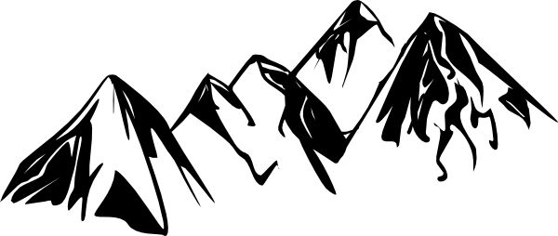In 1978, the U.S. Department of Energy began a study of Yucca Mountain, which is located 90 miles from Las Vegas, Nevada. The study was to determine if Yucca Mountain would be suitable for a long-term burial site for high-level radioactive waste. A three-dimensional (3-D) computer scale model of the site was used to simulate the Yucca Mountain area. The computer model study for Yucca Mountain included such variables as: the possibility of earthquakes, predicted water flow through the mountain, increased rainfall due to climate changes, radioactive leakage from the waste containers, and increased temperatures from the buried waste within the containers.

The containers that will be used to store the radioactive waste are designed to last 10,000 years. Within the 10,000-year time period, cesium and strontium, the most powerful radioactive emitters, would have decayed. Other isotopes found in the waste would decay more slowly, but are not powerful radioactive emitters. In 1998, scientists discovered that the compressed volcanic ash making up Yucca Mountain was full of cracks. Because of the arid climate, scientists assumed that rainwater would move through the cracks at a slow rate. However, when radioactive chlorine-36 was found in rock samples at levels halfway through the mountain, it was clear that rainwater had moved

quickly down through Yucca Mountain. It was only 50 years earlier when this chlorine-36 isotope had contaminated rainwater during atmospheric testing of the atom bomb. Some opponents of the Yucca Mountain plan believe that the uncertainties related to the many variables of the computer model result in limited reliability of its predictions.

However, advocates of the plan believe it is safer to replace the numerous existing radioactive burial sites around the United States with the one site at Yucca Mountain. Other opponents of the plan believe that transporting the radioactive waste to Yucca Mountain from the existing 131 burial sites creates too much danger to the United States. In 2002, after years of political debate, a final legislative vote approved the development of Yucca Mountain to replace the existing 131 burial sites.

1. State one uncertainty in the computer model that limits the reliability of this computer model.

2. Scientists assume that a manufacturing defect would cause at least one of the waste containers stored in the Yucca Mountain repository to leak within the first 1,000 years. State one possible effect such a leak could have on the environment near Yucca Mountain.

3. State one risk associated with leaving radioactive waste in the 131 sites around the country where it is presently stored.

4. If a sample of cesium-137 is stored in a waste container in Yucca Mountain, how much time must elapse until only 1/32 of the original sample remains unchanged?

5. The information states “Within the 10,000-year time period, cesium and strontium, the most powerful radioactive emitters, would have decayed.” Use information from Reference Table *N* to support this statement.

6. Why is water flow a crucial factor in deciding whether Yucca Mountain is a suitable burial site?

**Part V –Radiation in Your Life**

**Pearsons SuccessNet On-line**

**Curie Cures**

Understand gamma radiation and cancer treatment by watching the video online.

1. What is a Gamma Knife?

_____________________________________________________________

2. Why is gamma radiation an effective way to destroy cancer cells?

______________________________________________________________________________________________________________________________

**__________________________________________________________________**

**Page 897**

# 26 ___________________________________________

_____________________________________

_____________________________________

#27 ____________________________________________________________________________

# 28 ___________________________________________________________________________

________________________________________________________________

#29 __________________________________________________________________________

_______________________________________________________________

#31 ________________________________________________________________

________________________________________________________________

#32 __________________________________________________________________________

_______________________________________________________________

#33 __________________________________________________________________________

**Page 900**

#56 ___________________________________________________________________________

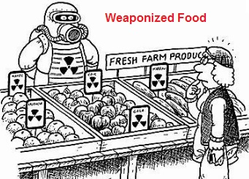 **Explain in your own words the meaning of the cartoon.**

**_______________________________________**

**_______________________________________**

**_______________________________________**

**_______________________________________**

**_______________________________________**